***Continuous random variavbles:***

Takes valves from an interval/serval intervals

Use a probability density function

--curve where are under the curve between two valves gives probability

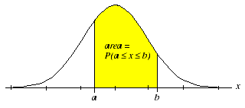

Table are under curve=1

Height of curve is always ≥0

Uniform random variable pdf is a constant function.

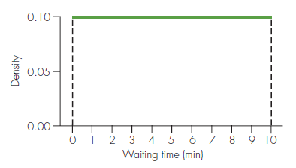 width x height =1

**Normal random variable**

Area🡪normal curve

Variable has normal distribution

Completely determined by µ=mean and σ=standard deviation

**Properties of normal distribution:**

🡪Symmetric, bell-shaped

🡪P(X≤µ)=P(X≥µ)=0.5

🡪P(X≤µ-d)=P(X≥µ+d) for any d≥0 d=distance

🡪Empirical Rule holds

* P(µ-σ≤X≤µ+σ)≈0.68
* P(µ-2σ≤X≤µ+2σ)≈0.95
* P(µ-3σ≤X≤µ+3σ)≈0.997

Cumulative rules:

